Table of Contents

Solutions 1

1 Screenshots 1

**List of Figures**

Figure 1: Working UI of the Plugs while running program.(1/2) 1

Figure 2: Working UI of the Plugs while running program.(2/2) 1

Solutions

# Screenshots

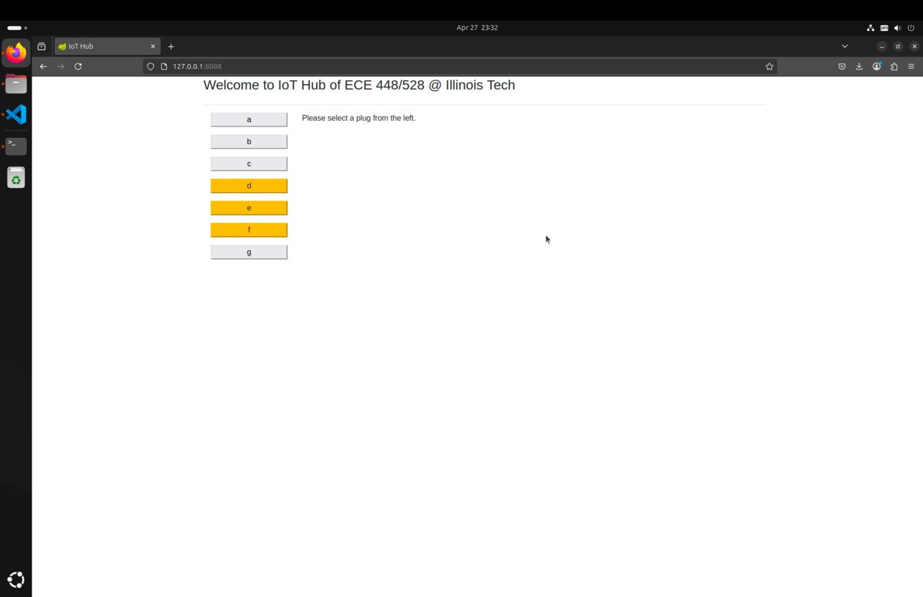

Figure 1: Working UI of the Plugs while running program.(1/2)

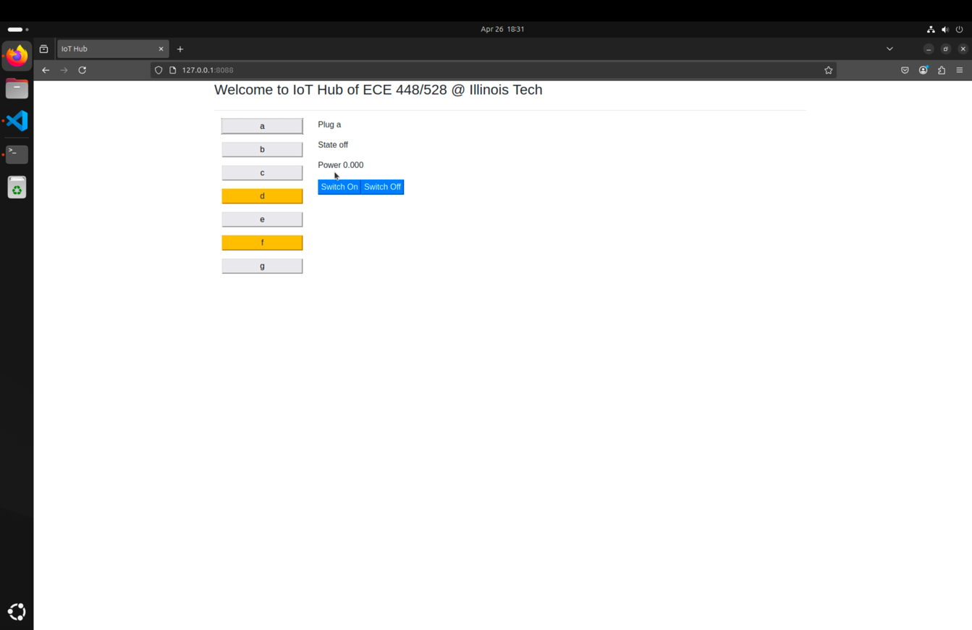

Figure 2: Working UI of the Plugs while running program.(2/2)